AMP: Super Simulator

Created by – Pramod Gopisetty

Version No - 1.0

Date – 4th November, 2016

Approval:

|  |  |  |  |
| --- | --- | --- | --- |
| Position | Name | Comment | Signoff |
| Project Manager |  |  |  |
| Developer |  |  |  |
| Client |  |  |  |
| DBA |  |  |  |

**Contents**

1 Purpose of the Project 4

2 Business Objective 4

3 Creation of ‘Super and retirement’ section 5

3.1 My retirement simulator 6

3.1.1 Calculate now 7

3.1.2 More super and retirement tools 7

3.1.3 My super simulator 7

4 My retirement simulator 7

4.1 Header of the simulator pages 7

4.2 Footer of the simulator pages 8

4.2.1 Sound 8

4.2.2 Explanation 8

4.2.3 Glossary 9

4.2.4 Navigation buttons 9

4.3 Simulator Pages in detail 10

4.3.1 Introduction Page 10

4.3.2 Age 11

4.3.3 Income 13

4.3.4 Super savings 13

4.3.5 Type of current super investment 14

4.3.6 Extra contributions 15

4.3.7 Projected retirement savings 17

5 Acronyms 19

# Purpose of the Project

The aim of this Project is to create an online Super Simulator for AMP. This online simulator assists the customers to estimate there future superannuation savings based on present situation.

# Business Objective

The business objective is to create ‘My Super Simulator’ within the AMP’s existing website. This tool should be added to Tools and calculators page. There is a menu button on the AMP homepage. When this is clicked, the following menu comes up which is appearing on the left of the screen.

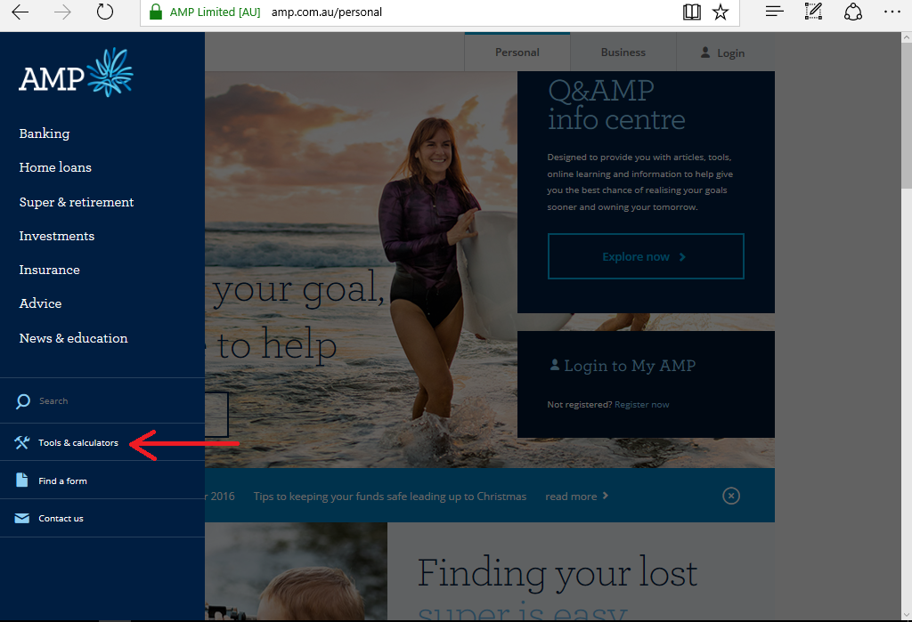

**Figure 1 – AMP Home Page**

# 

# Flow chart

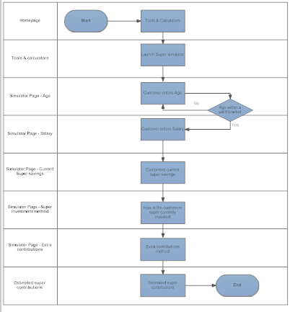

**Figure 2 – Flow chart**

# Creation of ‘Super and retirement’ section

A new section should be created in the Tools and calculators page between the two existing sections – Home loans and Investments. The heading for this section should be ‘Super and retirement’. The format of this section should be the same as Home loans section.

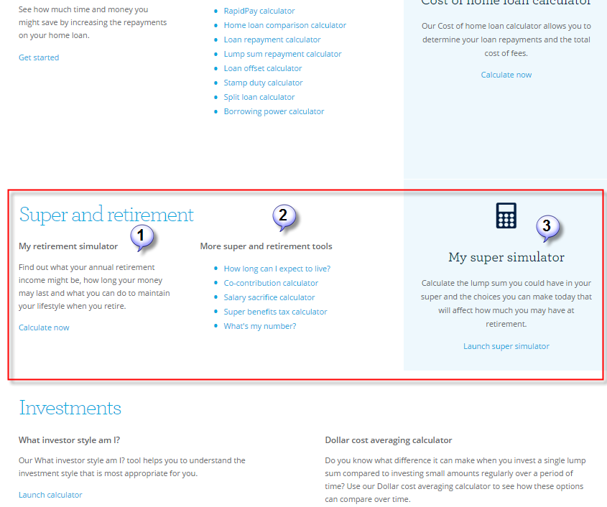

**There should be 3 subheadings in this section.**

1. My retirement simulator
2. More super and retirement tools
3. My super simulator

## My retirement simulator

This part should have the information - ‘Find out what your annual retirement income might be, how long your money may last and what you can do to maintain your lifestyle when you retire.’ The background color, font size and style are the same as the other sections within this page. Followed by this a new link should be created with the title ‘Calculate now’ which will lead the user to a new page – My retirement simulator.

### Calculate now

This link leads the customer to the My retirement simulator page. More information about this page is given below.

### More super and retirement tools

This section should only have 5 links. Each link should lead the customer to a new page.

### My super simulator

This section should have details about the super simulator. The information to be added in this section is “Calculate the lump sum you could have in your super and the choices you can make today that will affect how much you may have at retirement.” Followed by this a new link should be created with the title ‘Launch super simulator’ which will lead the user to a new page – My retirement simulator. Note: The ‘Calculate now’ link explained in Section 4.1.1 and the ‘Launch super simulator’ link should lead to the same My retirement simulator page.

# My retirement simulator

This is the page where the actual simulation starts. There are 8 simulation pages in total, out of which on first 6 simulation pages, the customer enters the information and the 7th simulation page gives the result of the estimated superannuation contributions based on the information entered by the customer on the first 6 pages.

## Header of the simulator pages

The title of the Page should be AMP My super simulator. The format of this is given below. The AMP area is a hyperlink which will lead to the AMP home page. This heading should be at the top left corner of the simulation windows. The title of the page and its location is the same across all the 7 simulation pages.

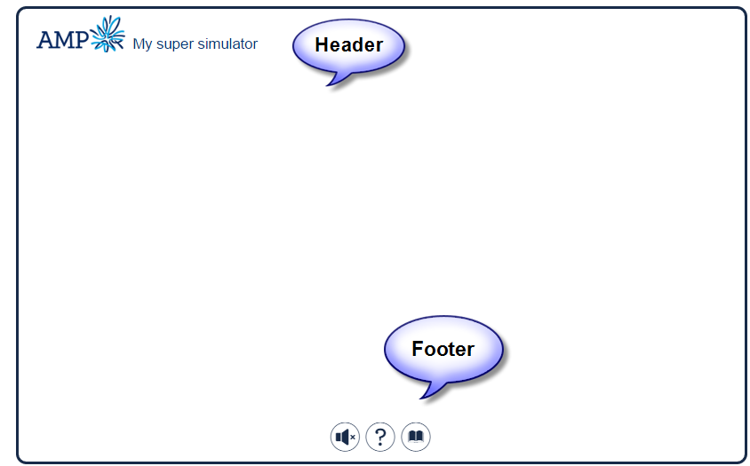

## Footer of the simulator pages

At the bottom-centre of the simulator pages, there should be 3 buttons -

* Sound
* Explanation
* Glossary



### Sound

A music file is played at the background, as soon as the customer sees the first page of the simulation window. The customer can mute the audio by clicking on the Sound button. The below pictures show when the sound is muted and when it is unmated. When the Sound is on, and if the customer rovers over this Sound icon, an option comes up stating ‘Mute Sound’ and if sound is already muted, an option stating ‘Unmute Sound’ should come up when the customer rover over this icon. When the sound is muted, an ‘x’ symbol should appear next to the sound icon.

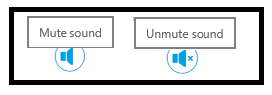

### Explanation

When this button is clicked, a detailed explanation of the corresponding simulator page is displayed. The information should appear on the same page at the bottom of the screen.



### Glossary

On clicking this icon, should lead to another lead page titled Support. In this page, the information about the AMP, FAQ’s and contact numbers of the support team are displayed.



### Navigation buttons

On the first simulator page, there should be a ‘Start’ button at the right bottom corner of the page. From the simulator pages 2 to 6, there should be a ‘Back’ button at the left bottom corner of the page and a ‘Next’ button at the right bottom of the page. On the last page, instead of a ‘Next’ button there should be a ‘Where to now?’ button.

Simulator Page – 1



Simulator Pages – 2 to 6



Simulator Page – 7



## Simulator Pages in detail

There are 8 simulator pages in total. First page is the Introduction Page and the 7th page is the results page where the customers estimated contributions are displayed. From simulator pages 2 to 4, a question should be displayed.

Two options are provided to the customers to enter their response. The first option is there is a sliding bar as shown below and the second option is they can hard code the value in the field below the sliding bar. There is preset information within the bar and they are rules and validations for field where the customer enters the information. Before the beginning of this bar, there should be a minus (-) sign and after the end of the bar, there should be a plus (+) sign.

The information on each page is explained in detail below. For simulator pages 2 to 4, the description is given in the below format.

* Question
* Minimum value
* Maximum value
* Default value
* Increment value each time a customer clicks on the + sign
* Decrement value each time a customer clicks on the – sign
* Explanation about the question

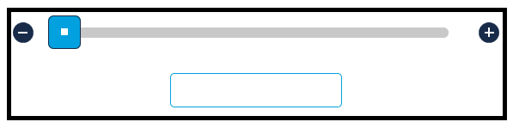

### Introduction Page

This is only an introductory page, where the customer should have only 1 option to select – Start button at the bottom right part of the simulator page.

At the centre of the page, it should come up with a question – “How much do you need to retire?” Below this question, a 6 digit rolling icon should be created in a $ format.

A Start button should be created on this page at the right bottom location. This is the only button which allows the customers to proceed to the next screen.

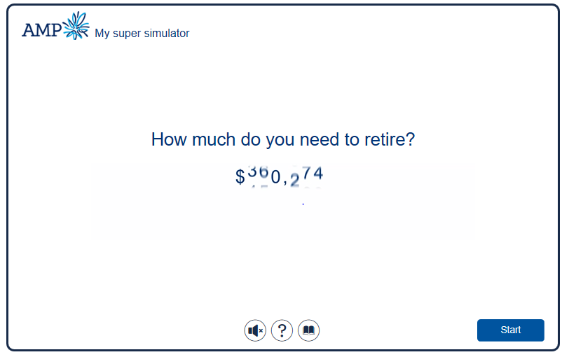

#### Rules & Conditions

|  |  |  |
| --- | --- | --- |
| **Introduction Page** | **Rules** | **Conditions** |
| Start is the only button; the customer can select to go to the next simulator screen. |  |
| The header and footer of this page still have the same functionality as detailed in 4.1 Header of the simulator pages & 4.2 Footer of the simulator pages. |  |

### Age

From simulator pages 2 to 4, the format of the page should look like the below snapshot.

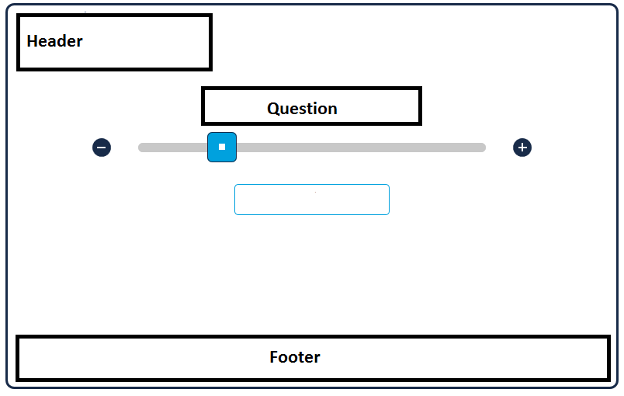

Question - “How old are you?”

Minimum value - 20

Maximum Value - 70

Default value - 32

Explanation - Nill

Increment value each time a customer clicks on the + sign – ‘+1’

Decrement value each time a customer clicks on the – sign – ‘-1’

|  |  |  |
| --- | --- | --- |
| **Simulator Page 2 - Age** | **Rules** | **Conditions** |
| **Field validations** | If the customer decides to enter the value on the field below the slide bar, the minimum value they can enter is 20 and the maximum value is 70. | If a value is entered which is outside these limitations an error message stating '**Please enter a value between 20 and 70**' should come up below this field. |
| This field cannot be blank. Customer should input their age before they go further. | If no value is entered, an error message stating '**Please enter a value between 20 and 70**' should come up below this field. |

### Income

Question - “How much do you earn per year?”

Minimum value - $0

Maximum Value - $500,000

Default value - $50,000

Explanation - “We’re looking for your annual salary before tax so that we can calculate your compulsory supper contributions.”

Increment value each time a customer clicks on the + sign – ‘+1000’

Decrement value each time a customer clicks on the – sign – ‘-1000’

|  |  |  |
| --- | --- | --- |
| **Simulator Page 3 - Income** | **Rules** | **Conditions** |
| **Field validations** | If the customer decides to enter the value on the field below the slide bar, the minimum value they can enter is $0 and the maximum value is $2,500,000. | If a value is entered which is outside these limitations an error message stating 'Please enter a value between'$0' and $500,000' |
| This field cannot be blank. Customer should input their valid income before they go further. | If no value is entered, an error message stating '**Please enter a value between'$0' and $500,000'** should come up below this field. |

### Super savings

Question - “How much have you saved in your super so far?”

Minimum value - $0

Maximum Value - $2, 500,000

Default value - $0

Explanation - “If you have more than 1 super fund, please enter the total found.”

Increment value each time a customer clicks on the + sign – ‘+1000’

Decrement value each time a customer clicks on the – sign – ‘-1000’

|  |  |  |
| --- | --- | --- |
| **Simulator Page 3 – Super savings** | **Rules** | **Conditions** |
| **Field validations** | If the customer decides to enter the value on the field below the slide bar, the minimum value they can enter is $0 and the maximum value is $2,500,000. | If a value is entered which is outside these limitations an error message stating '**Please enter a value between'$0' and $2,500,000'** |
| This field cannot be blank. Customer should input their savings before they go further. | If a value is entered which is outside these limitations an error message stating '**Please enter a value between'$0' and $2,500,000'** |

### Type of current super investment

Question - “How is your super currently invested?”

On this screen, there are 6 options available on the bar slide. Under each option, the percentages of Growth assets and Defensive asset are displayed along with Relative risk. To the left of this information, the Growth assets percentage for each type is shown in a Pie chart. A brief explanation should also be given to the customers on the same screen.

**Page layout**

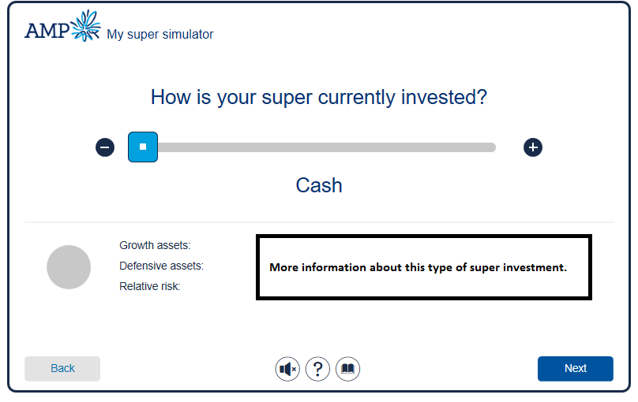

The 5 options available are Cash, Conservative, Cautious, Moderately conservative, Balanced, Moderately Aggressive and Aggressive. More information about each of these types is detailed in the Appendix section. By default, Balanced option should be displayed when the customer comes to this page.

|  |  |  |
| --- | --- | --- |
| **Currently Super Investment type** | **Rules** | **Conditions** |
| **Field validations** | There are 7 options in this page and the customer can only select 1. |  |

### Extra contributions

Question -Tell us the amount and type of extra contributions you make to your super per year.

Here the customer enters the amount they are contributing either on the sliding bar or on the field below the bar.

This page there should be 2 options i.e. Salary Sacrifice and Personal Contributions. The customer can only tick 1 of these options in an instance. Below each of this option, the amount the customer select is displayed.

The minimum value and the maximum values are different for the 2 options above.

For Salary Sacrifice –

Minimum value - $0

Maximum Value - $50,000

For Personal contributions –

Minimum value - $0

Maximum Value - $180,000

**Page Layout**

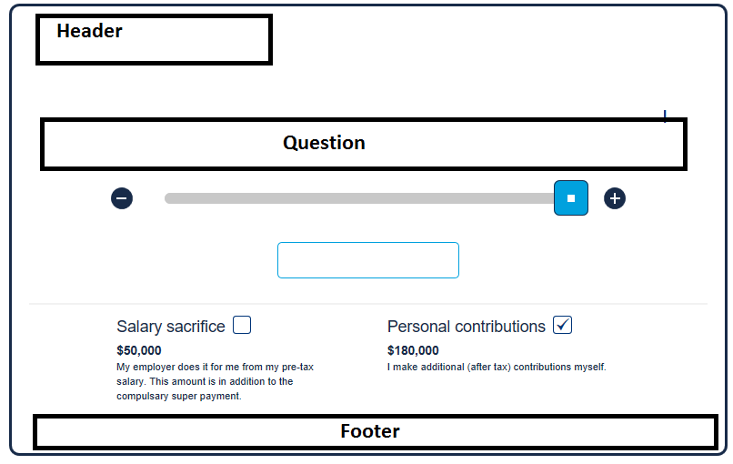

|  |  |  |
| --- | --- | --- |
| **Extra contributions** | **Rules** | **Conditions** |
| **Field validations** | If a customer ticks the Salary sacrifice option, the minimum and maximum amount the customer can enter is $0 and $50,000 respectively. | If a value is entered which is outside these limitations an error message stating '**Please enter a value between'$0' and $50,000'** if your contribution type is Salary sacrifice |
| If a customer ticks the personal contribution option, the minimum and maximum amount the customer can enter is $0 and $180,000 respectively. | If a value is entered which is outside these limitations an error message stating '**Please enter a value between'$0' and $180,000'** if your contribution type is Salary sacrifice |
| When customer selects Salary sacrifice option, the amount entered by the customer should be displaced below the Salary sacrifice option within the same window and the Dollar value under Personal contributions should be 0 and vice versa |  |

### Projected retirement savings

This is the page where the final outcome is displayed in terms of based on the information provided. The information provided by the customer is shown on the right top of the screen.

Below this customer information, the customers can enter the information using the sliding bars to get an estimate instantly. Below are the fields where the customer enters the information for instant quote.

An estimate is provided based on the 3 type of current markets – Weak markets, average markets and strong markets.

**Salary Sacrifice contributions**

Minimum value - $0

Maximum value - $50,000

**Personal contributions**

Minimum value - $0

Maximum value - $180,000

**Lump sum contributions**

Minimum value - $0

Maximum value - $180,000

**Investment mix**

Options available – Cash, Conservative, Cautious, Moderately conservative, Balanced, Moderately aggressive, Aggressive

**Retirement age**

Minimum value - 55

Maximum value - 75

**Page Layout**

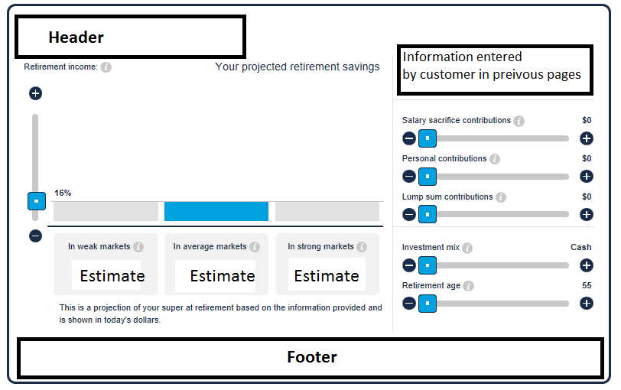

The footer is slightly different on this one, instead of the Next button, there should be a ‘Where to button’ which will lead the customers to the next page. On the next page, it should display 2 buttons ‘Strategies and ideas’, ‘Find a financial planner’. Below these buttons, it should give the customers an option to contact AMP with their contact number.

# Figure Index

# Acronyms

FAQ - Frequently asked questions.